
Bear News
Index Elementary School
November 2025
Together We Are Inspiring Life-Long Learners

Pictures from the Index School Property Clean-up.

Creating a usable space to provide additional opportunities for our students for Outdoor Education.

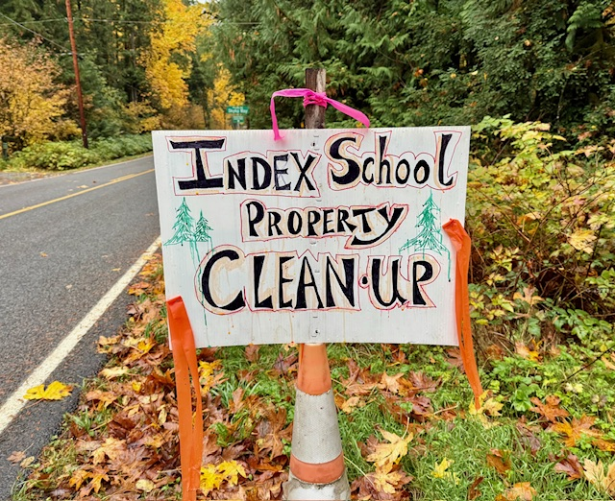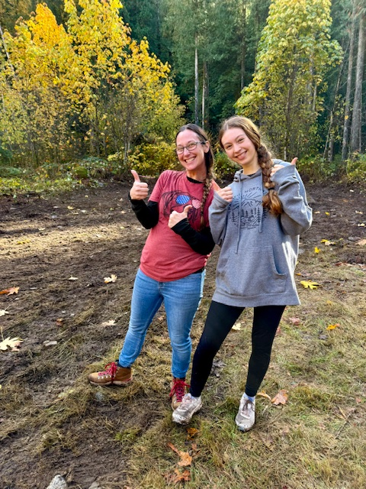



To view the latest monthly events available at the Sultan Library and online, please visit the Sno-Isle website at:
sno-isle.bibliocommons.com/v2/events?q=%22sultan%20library%22

Important Dates for November

November 11 Veteran’s Day (No School)
November 13 Game Night (4:00 – 6:00 p.m.)
November 26, 27, 28 Thanksgiving Holiday (No School)

Early Releases & Dismissals
November 10 11:30 Early Release before holiday November 25 11:30 Early Release before holiday
November 7, 14, 21 1:30 Friday Early Dismissals

Happy Birthday to…. 

November 19 Emily Elias
November 20 Kaleb McDougall

Index School District does not discriminate in any programs or activities on the basis of sex, race, creed, religion, color, national origin, age, veteran or military status, sexual orientation, gender expression or identity, disability, or the use of a trained dog guide or service animal and provides equal access to the Boy Scouts and other designated youth groups. The following employee has been designated to handle questions and complaints of alleged discrimination: Civil Rights Coordinator/Title IX Coordinator/504 Coordinator/HIB Coordinator/McKinney Vento: Gerry Grubbs – Superintendent/Principal, 360-793-1330,. Address: 436 Index Ave. Index, WA 98256. Index School District will always take steps to assure the national origin persons who lack English Language skills can participate in all education programs, services and activities. For information regarding translation services or transitional bilingual education programs, contact our superintendent.

