
Bear News
Index Elementary School
January 2026
Together We Are Inspiring Life-Long Learners

-Students enjoying Music Class-

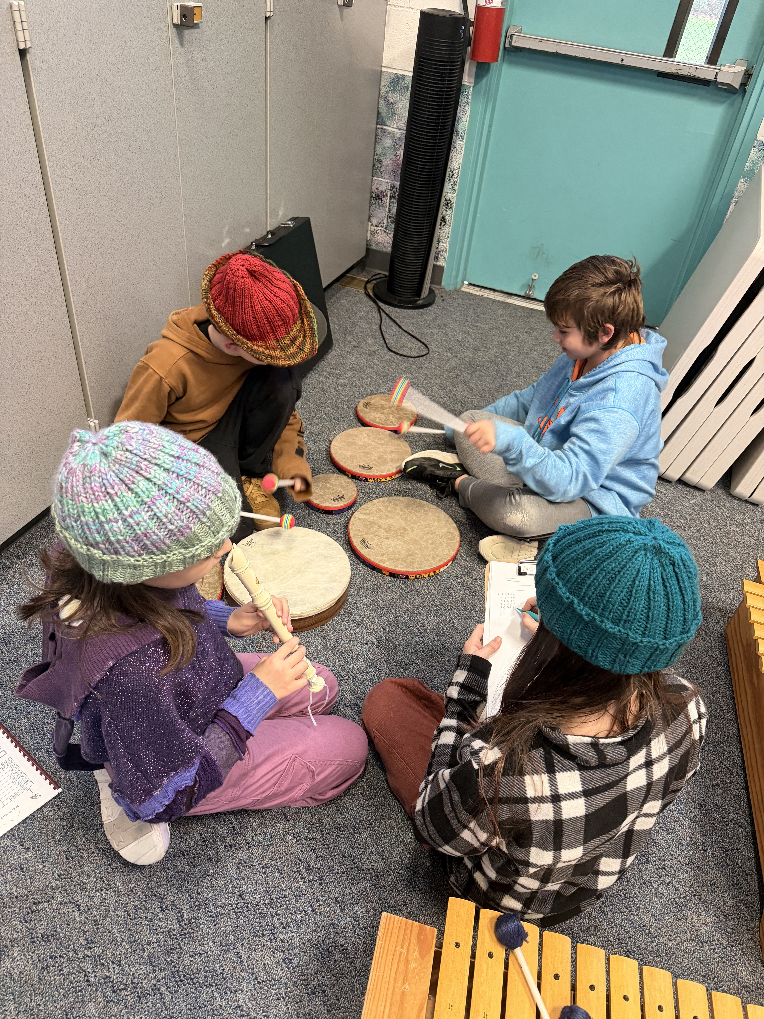

Looking forward to the New Year!!!!!

To view the latest monthly events available at the Sultan Library and online, please visit the Sno-Isle website at:
sno-isle.bibliocommons.com/v2/events?q=%22sultan%20library%22

Important Dates for January

January 19 Martin Luther King Jr. Day, No School
January 28 Shack Field Trip 9:30 am- 2:30 pm

Early Releases & Dismissals
January 9 1:30 Early Release
January 16 11:30 Early Dismissal before holiday
January 23 1:30 Early Release
January 30 1:30 Early Release

Happy Birthday to…. 

January 5 Maeve Nierosa-Steinmetz
January 8 Oscar Bolick
January 12 Carly Elias

Index School District does not discriminate in any programs or activities on the basis of sex, race, creed, religion, color, national origin, age, veteran or military status, sexual orientation, gender expression or identity, disability, or the use of a trained dog guide or service animal and provides equal access to the Boy Scouts and other designated youth groups. The following employee has been designated to handle questions and complaints of alleged discrimination: Civil Rights Coordinator/Title IX Coordinator/504 Coordinator/HIB Coordinator/McKinney Vento: Gerry Grubbs – Superintendent/Principal, 360-793-1330,. Address: 436 Index Ave. Index, WA 98256. Index School District will always take steps to assure the national origin persons who lack English Language skills can participate in all education programs, services and activities. For information regarding translation services or transitional bilingual education programs, contact our superintendent.

