
Bear News
Index Elementary School
February 2026
Together We Are Inspiring Life-Long Learners

-Schaak Field Trip-

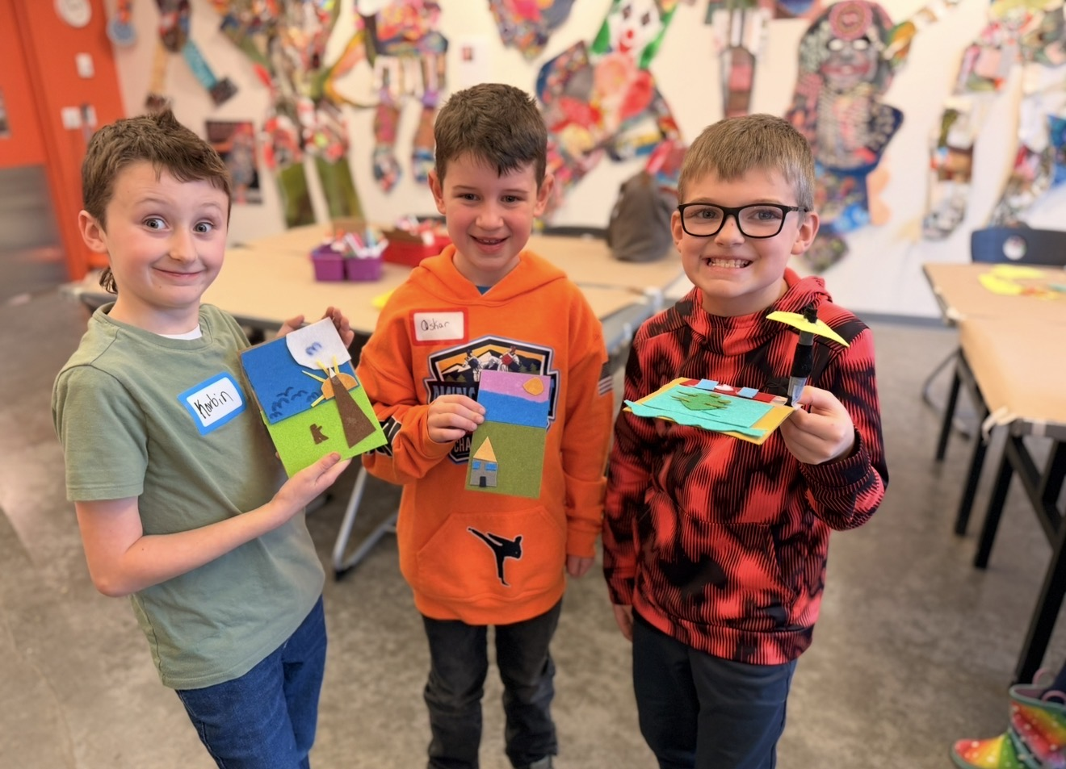

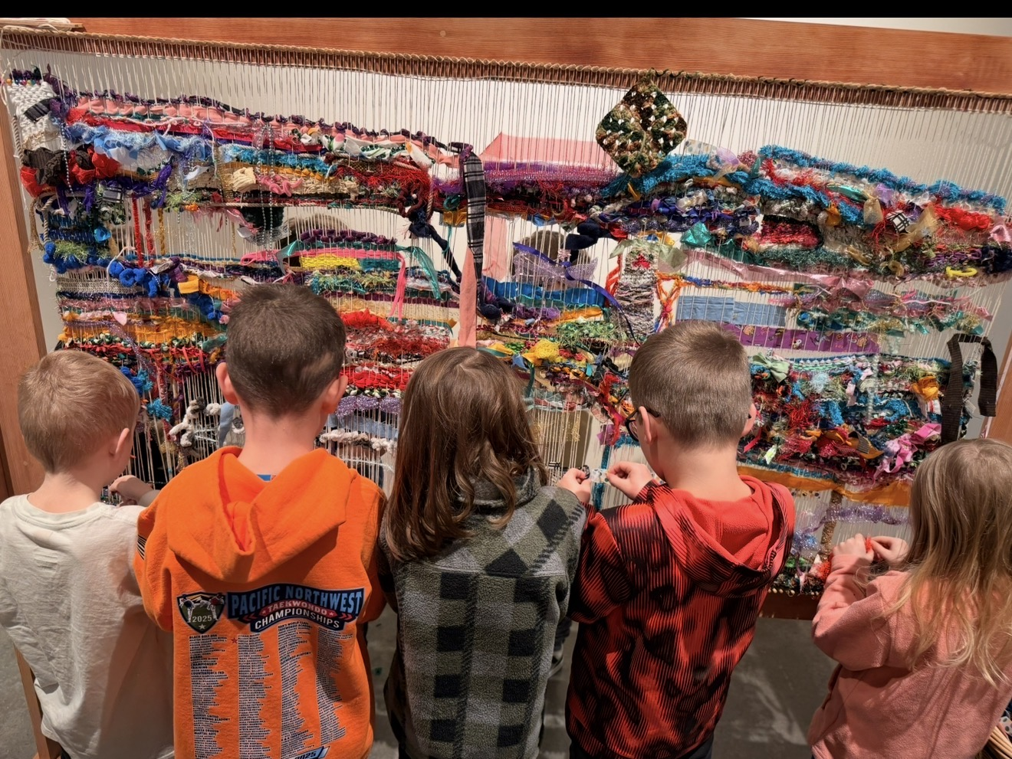

To view the latest monthly events available at the Sultan Library and online, please visit the Sno-Isle website at:
sno-isle.bibliocommons.com/v2/events?q=%22sultan%20library%22

Important Dates for February

February 4, 11, 18, 25 Swim Lessons
February 13 Mid Winter Break (No School)
February 16 President’s Day (No School)

Early Releases & Dismissals

February 12 11:30 Early Dismissal before holiday
February 20 1:30 Early Release
February 27 1:30 Early Release

Happy Birthday to…. 

February 20 Colton McDougall

Index School District does not discriminate in any programs or activities on the basis of sex, race, creed, religion, color, national origin, age, veteran or military status, sexual orientation, gender expression or identity, disability, or the use of a trained dog guide or service animal and provides equal access to the Boy Scouts and other designated youth groups. The following employee has been designated to handle questions and complaints of alleged discrimination: Civil Rights Coordinator/Title IX Coordinator/504 Coordinator/HIB Coordinator/McKinney Vento: Gerry Grubbs – Superintendent/Principal, 360-793-1330,. Address: 436 Index Ave. Index, WA 98256. Index School District will always take steps to assure the national origin persons who lack English Language skills can participate in all education programs, services and activities. For information regarding translation services or transitional bilingual education programs, contact our superintendent.

