
Bear News
Index Elementary School
December 2025
Together We Are Inspiring Life-Long Learners

Index students honoring our veterans on Veteran’s Day

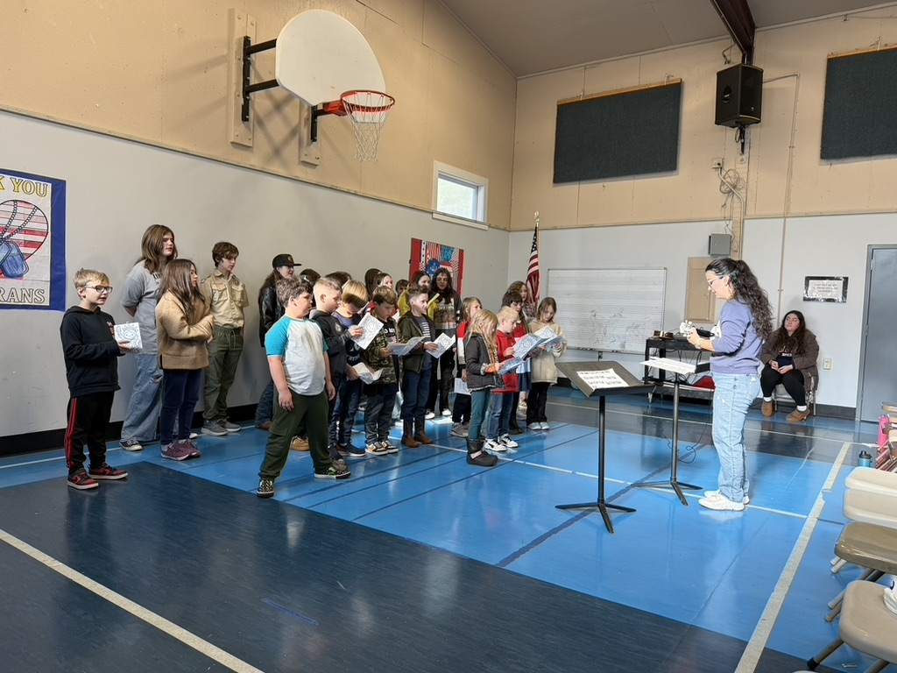

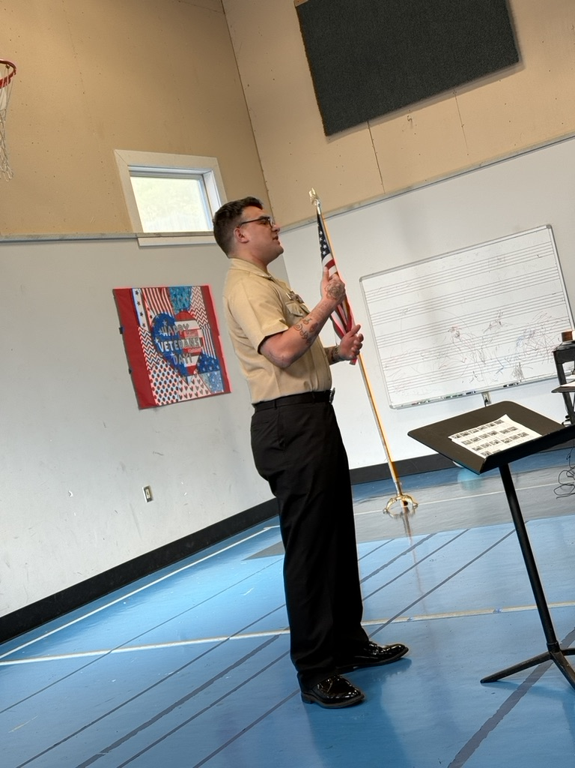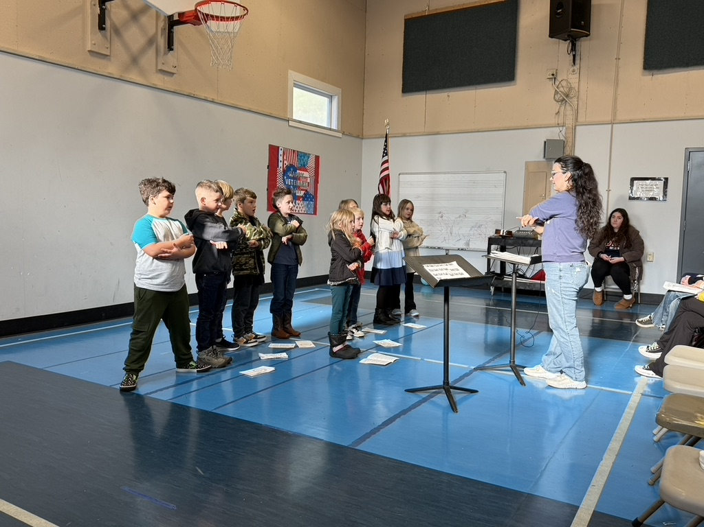

To view the latest monthly events available at the Sultan Library and online, please visit the Sno-Isle website at:
sno-isle.bibliocommons.com/v2/events?q=%22sultan%20library%22

Important Dates for December

December 3, 4, 5 Conferences (early dismissal 11:30 am)
December 17 Craft Day
December 18 Winter Concert
December 22 – Jan 2 Winter Break

Early Releases & Dismissals
December 3, 4, 5 11:30 Early Dismissals December 12 1:30 Early Release
December 19 11:30 Early Dismissal before holiday break
Happy Birthday to…. 

December 6 Eva O’Hara
December 8 Kallie Demers
December 13 Hailey Schlegel
December 18 Max Nelson
December 28 Elliott D’Ambra

Index School District does not discriminate in any programs or activities on the basis of sex, race, creed, religion, color, national origin, age, veteran or military status, sexual orientation, gender expression or identity, disability, or the use of a trained dog guide or service animal and provides equal access to the Boy Scouts and other designated youth groups. The following employee has been designated to handle questions and complaints of alleged discrimination: Civil Rights Coordinator/Title IX Coordinator/504 Coordinator/HIB Coordinator/McKinney Vento: Gerry Grubbs – Superintendent/Principal, 360-793-1330,. Address: 436 Index Ave. Index, WA 98256. Index School District will always take steps to assure the national origin persons who lack English Language skills can participate in all education programs, services and activities. For information regarding translation services or transitional bilingual education programs, contact our superintendent.

