
Bear News
Index Elementary School
September 2025
Together We Are Inspiring Life-Long Learners

WELCOME BACK!!!

We are off to a new and exciting year at the Index School District! Below you see Molly sporting her bear wear and you can too. Every Tuesday wear your teal or bear wear to show your school spirit. For bear wear, check out the following link.
https://indexelementaryschool.printful.me/

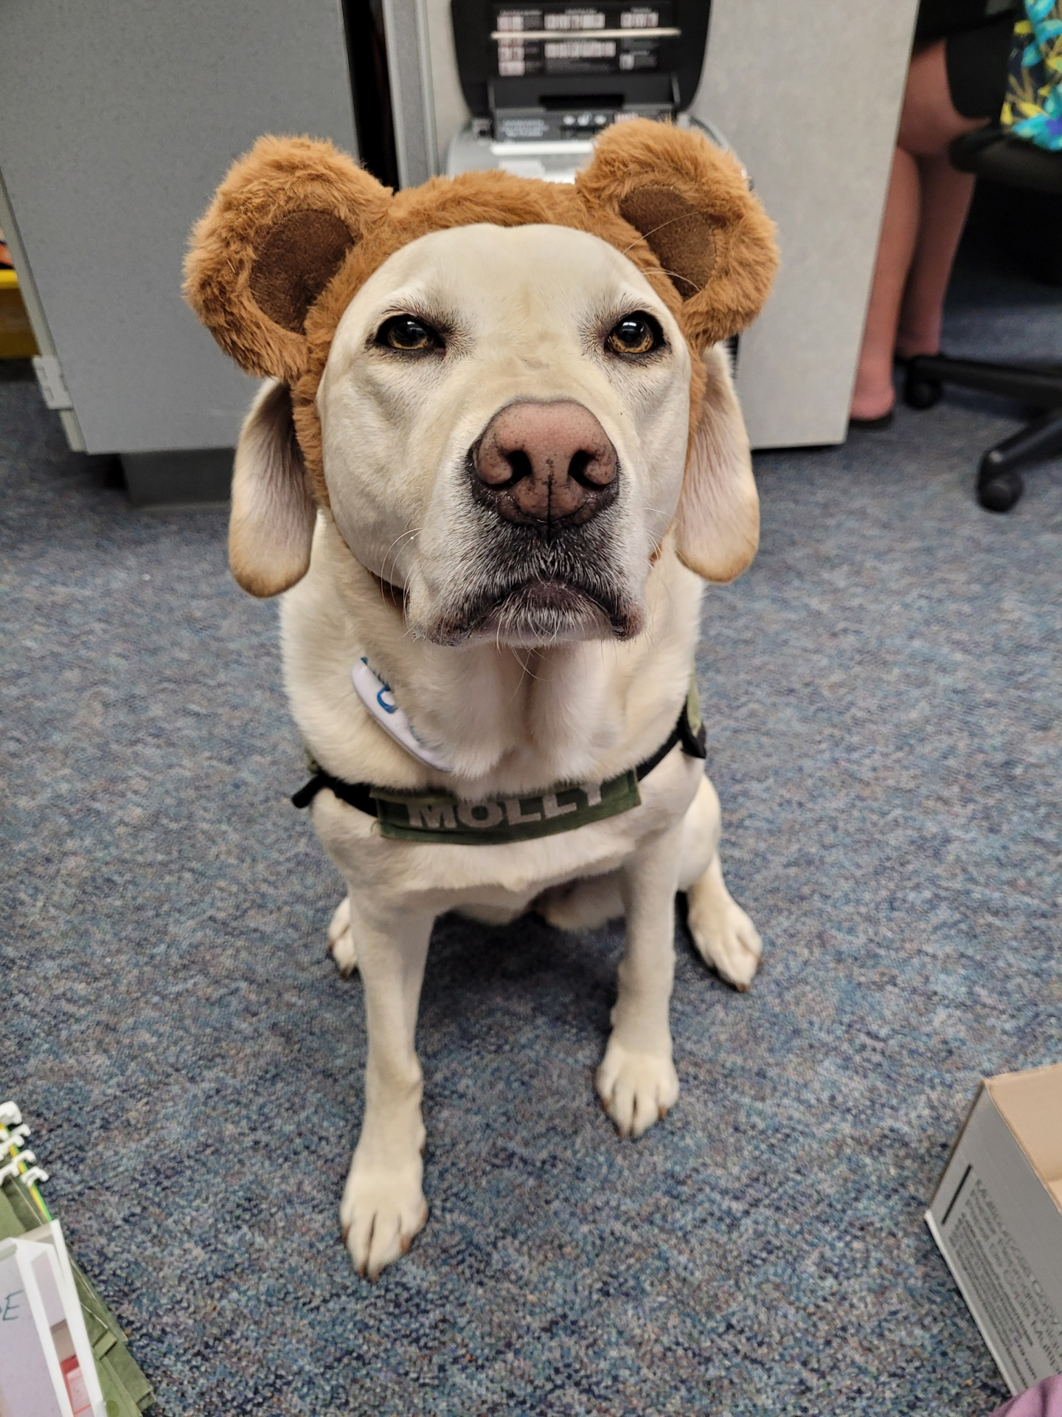

To view the latest monthly events available at the Sultan Library and online, please visit the Sno-Isle website at:
sno-isle.bibliocommons.com/v2/events?q=%22sultan%20library%22

Important Dates for September

September 18th Open House @ 6:00 pm

Early Releases & Dismissal
September 5, 12, 19, & 26 Early Dismissals @ 1:30 p.m.

Happy Birthday to…. 

Daniel Woolworth September 12

Index School District does not discriminate in any programs or activities on the basis of sex, race, creed, religion, color, national origin, age, veteran or military status, sexual orientation, gender expression or identity, disability, or the use of a trained dog guide or service animal and provides equal access to the Boy Scouts and other designated youth groups. The following employee has been designated to handle questions and complaints of alleged discrimination: Civil Rights Coordinator/Title IX/504 Coordinator: Gerry Grubbs – Superintendent/Principal, 360-793-1330,. Address: 436 Index Ave. Index, WA 98256. Index School District will always take steps to assure the national origin persons who lack English Language skills can participate in all education programs, services and activities. For information regarding translation services or transitional bilingual education programs, contact our superintendent.

