
Bear News
Index Elementary School
June 2025
Together We Are Inspiring Life-Long Learners

Hiking Heybrook Ridge

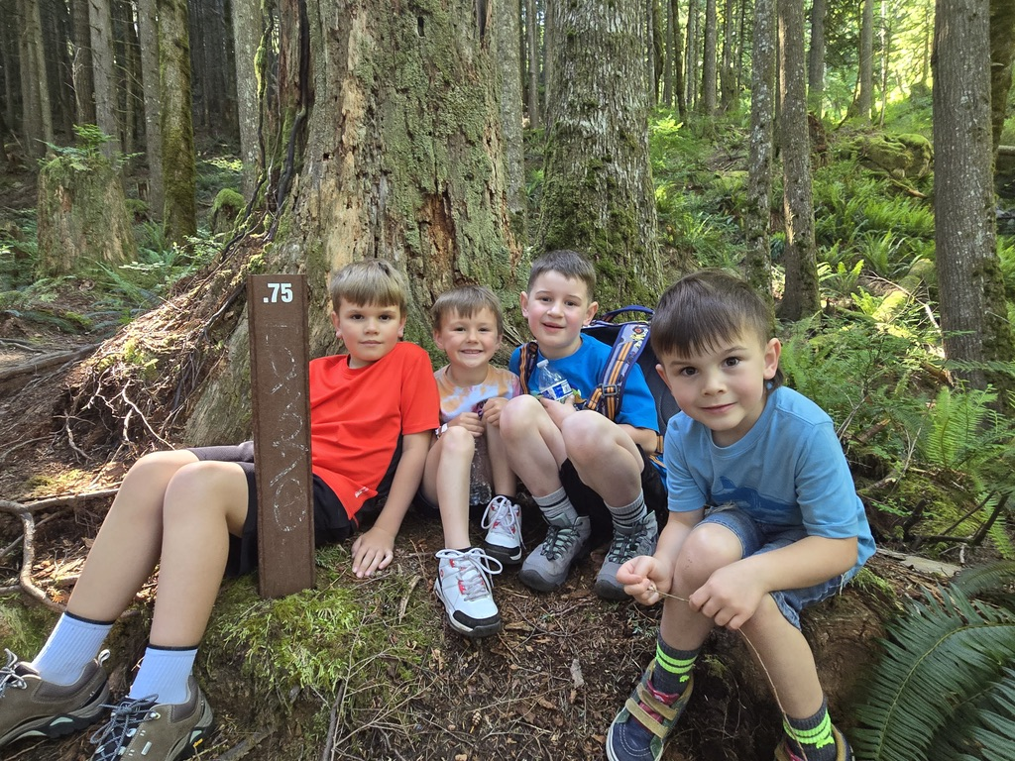

Index School District does not discriminate in any programs or activities on the basis of sex, race, creed, religion, color, national origin, age, veteran or military status, sexual orientation, gender expression or identity, disability, or the use of a trained dog guide or service animal and provides equal access to the Boy Scouts and other designated youth groups. The following employee has been designated to handle questions and complaints of alleged discrimination: Civil Rights Coordinator/Title IX/504 Coordinator: Gerry Grubbs – Superintendent/Principal, 360-793-1330,. Address: 436 Index Ave. Index, WA 98256. Index School District will always take steps to assure the national origin persons who lack English Language skills can participate in all education programs, services and activities. For information regarding translation services or transitional bilingual education programs, contact our superintendent.
To view the latest monthly events available at the Sultan Library and online, please visit the Sno-Isle website at:
sno-isle.bibliocommons.com/v2/events?q=%22sultan%20library%22

Important Dates for June

June 3 Spring Concert
June 12 Field Day
June 16 Last Day of School (w/early release)

Early Releases & Dismissal
June 4, 11 Early Dismissals @ 1:30 p.m.
June 16 Early Release @ 11:30 a.m.

Happy Birthday to…. 

Maxwell Keeley June 2nd
Lucas George-O’Hara June 25th

Please be sure to turn in your Renewal Registration paperwork for the 25-26 school year as well as your Choice Transfer releasing your child to come to the Index School District.

