
Bear News
Index Elementary School
March 2025
Together We Are Inspiring Life-Long Learners

On the 26th of February, students had fun with the introduction to the Snohomish Transit System!!!
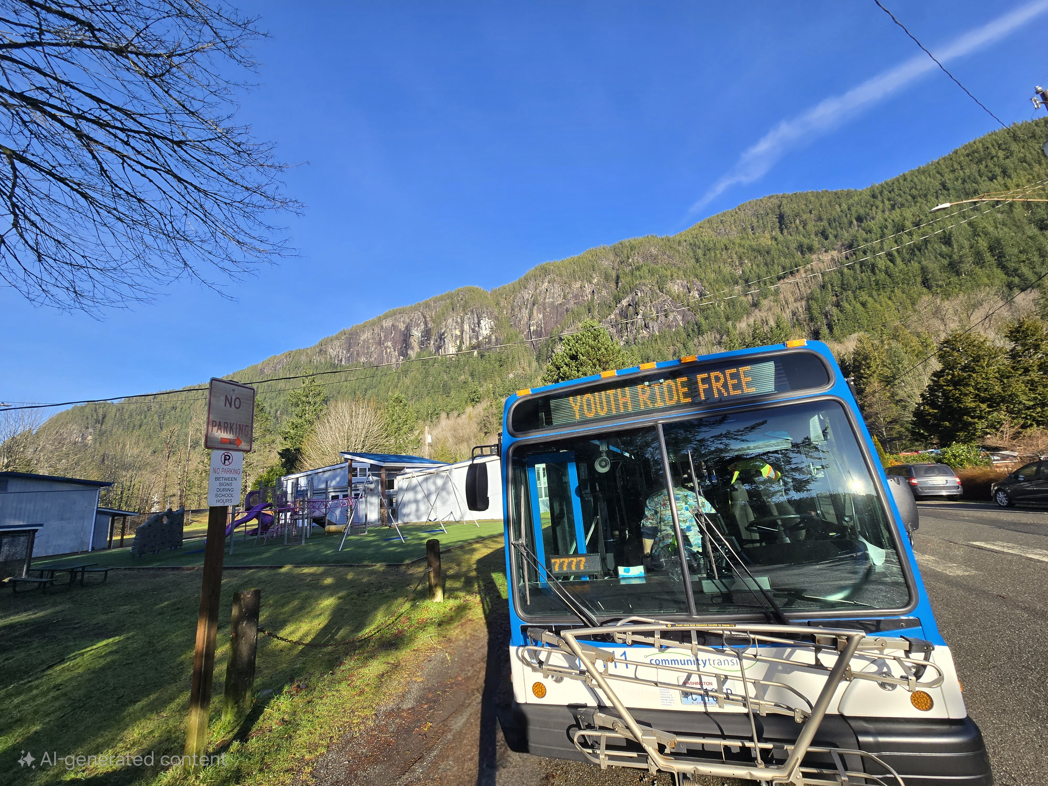

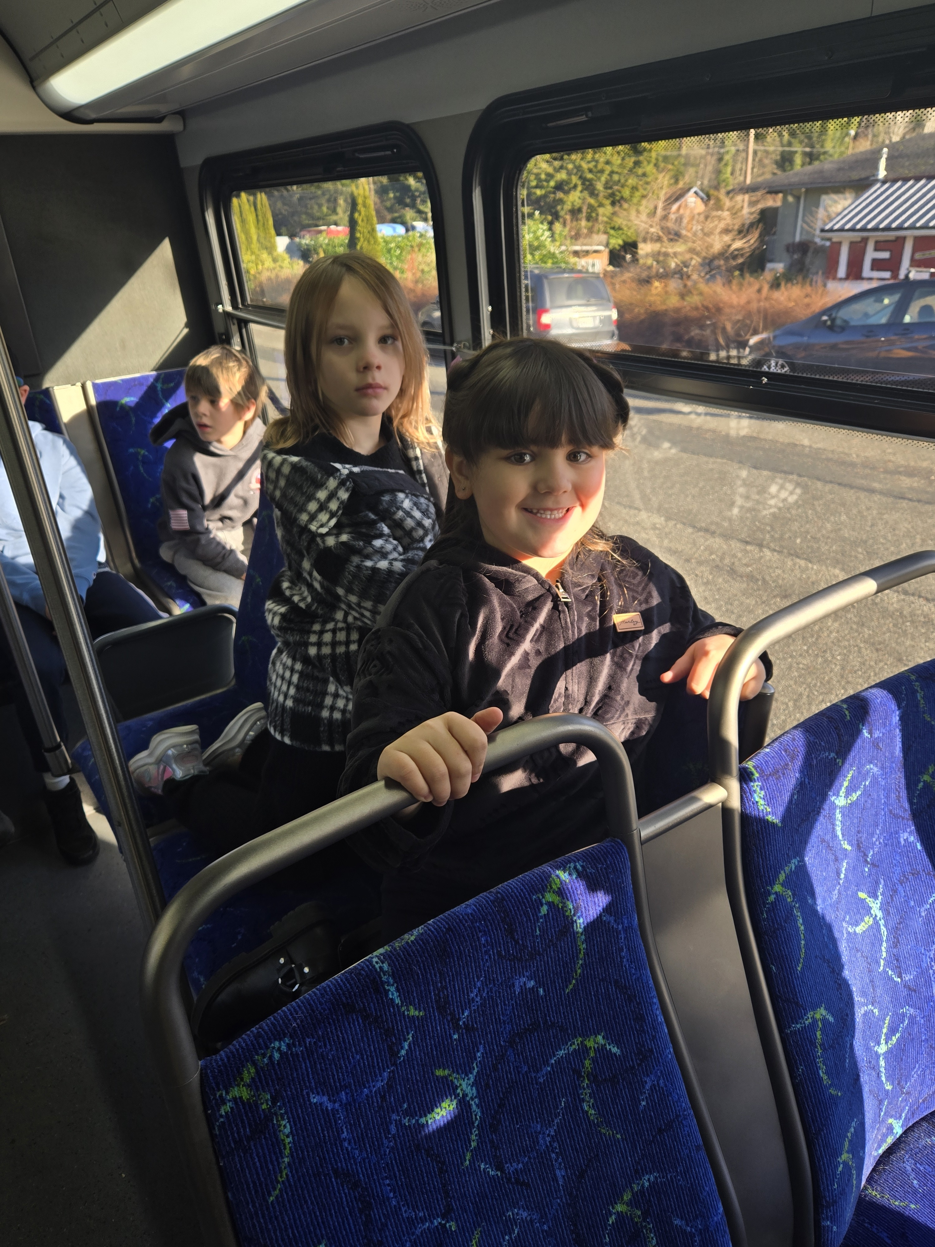
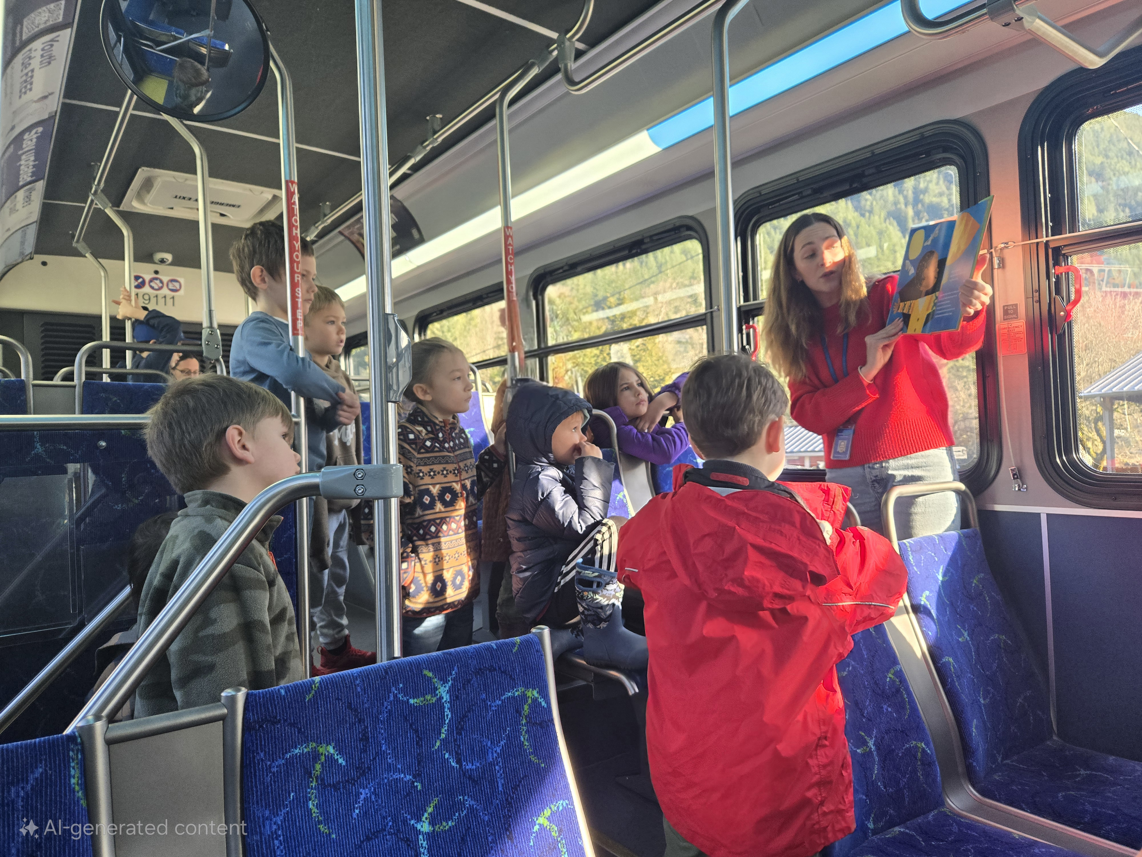



Index School District does not discriminate in any programs or activities on the basis of sex, race, creed, religion, color, national origin, age, veteran or military status, sexual orientation, gender expression or identity, disability, or the use of a trained dog guide or service animal and provides equal access to the Boy Scouts and other designated youth groups. The following employee has been designated to handle questions and complaints of alleged discrimination: Civil Rights Coordinator/Title IX/504 Coordinator: Gerry Grubbs - Superintendent, 360-793-1330,. Address: 436 Index Ave. Index, WA 98256. Index school District will always take steps to assure the national origin persons who lack English Language skills can participate in all education programs, services and activities. For information regarding translation services or transitional bilingual education programs, contact our superintendent.
To view the latest monthly events available at the Sultan Library and online, please visit the Sno-Isle website at:
sno-isle.bibliocommons.com/v2/events?q=%22sultan%20library%22
Important Dates for March

March 3, 10 Swimming Lessons
March 12, 13, 14 Conferences
March 27 Smile Mobile Assembly
March 31 (to Apr. 4) 1st Day of Spring Break

Early Releases & Dismissal
March 12, 13, 14 Early Releases for conferences @
11:30 a.m.
March 23 Early Release before Spring Break
@ 11:30 a.m.
March 5, 19, 26 Early Dismissals @ 1:30 a.m.

Happy Birthday to…. 

(No Birthdays for the month of March)

Anytime your child(ren) are to be absent, please call the office at (360) 793-1330 or email Connie in the office at cfehrenbach@index.k12.wa.us. If you are going to be late, and your child eats hot lunch, we must know before 8:30 a.m. Anything after 8:30 am. will require a cold lunch be brought with your child as a substitution for that day.

(We’re not quite done with the winter weather) In case you are not signed up for FlashAlert, below are directions. This automatically keeps you informed of the latest school closures and delays sent directly to your phone and/or computer.

Emergency Weather

Emergency Weather – What to do?
In the event of a school emergency or for school schedule changes due to adverse weather conditions and/or other emergency situations connect to FlashAlert.net for updated communications.
Note: If you are signed up to FlashAlert Newswire, you will automatically receive information about delays or closures on your phone and/or computer.

Index School on FlashAlert.net
Weather / Snow Days
This is a good time of year to remind you that Index is a part of the Puget Sound Emergency Communications System. During periods of extreme weather conditions, school will be delayed or closed. In addition, buses may run on an abbreviated schedule. Here is a list of radio, TV stations and websites you can use for up-to-the-minute information and/or changes.
- Radio – AM — KCIS 630 – KAPS 660 – KIRO 710 – KIXI 880 – KOMO 1000 – KYCW 1090 KRKO 1380 – KBRC 1430
- Radio – FM — KPLU 88.5 – KSER 90.7 – KLSY 92.5 – KUBE 93.3 – KMPS 94.1 – KBSG 97.3 – KMTT 103.7 – KCMS 105.3 – KRWM 106.9 –
- TV Stations – KOMO 4 – KING 5 / KONG 6 – KIRO 7 – KVOS 12 – KCPQ 13

(DIRECTIONS TO CONNECT)
- Go to the Flashalert.net website
- In upper left corner, click on View Local News
- Choose Seattle-Western Washington
- (Under Search) Choose Island & Snohomish Co. School District
- Choose Index SD
- Under Primary email address for new acount, put in email address for alerts to be sent.
- In the signup page, input your confirmed email address and password.
- Click Create Your Account, and you are done. (At this point, you can request a test email be sent to you through the app). The setup will walk you through this.

